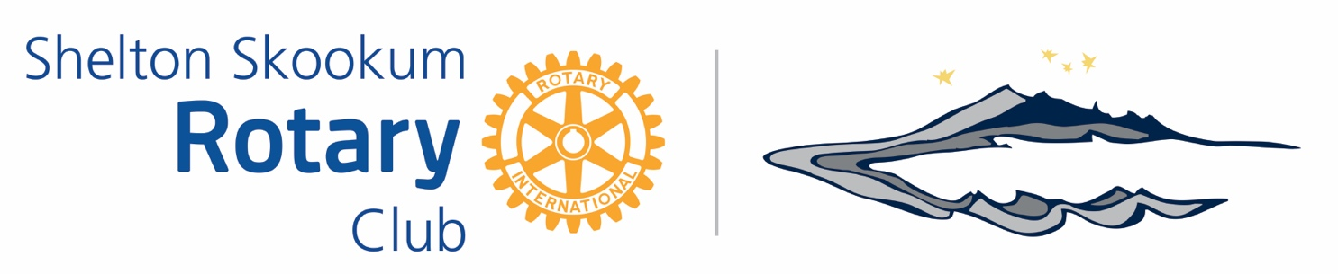
Community Grant Application
Your OysterFest Dollars at Work
The Community Grants committee meets quarterly, and requests must be submitted by the 15th of June, September, December & March. If the request is received after the deadline, it will be considered the following quarter.
Priority is given to:
- Mason County organizations
- Causes that will benefit larger numbers of people
- Causes that provide a direct tangible benefit to the community
- Causes that have promise for long term operation and service to the community
- Organizations with humanitarian goals.
Organization must have a 501 (c) (3) tax status. This application is not for single beneficiaries, or for organizations with political or religious pursuits. Organizations that have received funds previously will be assigned a lower priority for additional funds.
Name of Organization: __________________________________________
Amount Requested: ________________ Date Requested: ______________________
501 (c)(3) number: ________________________
Applicant Name/Title: _____________________/_____________________
Mailing Address: _______________________________________________
Phone: ____________________ Email: _______________________________
Please describe how the funds will specifically be used and why this project is important to our community. (i.e. when and where the funds be used. Who will be involved and what exactly the funds will pay for.)

Please send completed applications to skookumrotary.grants@gmail.com or
mail to Skookum Rotary, Attn: Community Grants at PO Box 849, Shelton, WA 98584

